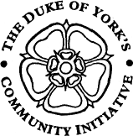
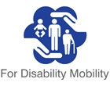

FDM – For Disability Mobility
FDM
For Disability Mobility
Charity No 1067438

Supporting Health, Choice, Independence & Social Inclusion
through accessible community transport

106 STONE BRIG LANE, ROTHWELL, LEEDS, LS26 0UE
Telephone 0113 288 9000

1997 2017
20 years providing
Miles of
Smiles

Email: info@fdmbus.org.uk Website: www.fdmbus.org.uk

Newsletter February 2018

FDM Social Club Panto Trips a Huge Success

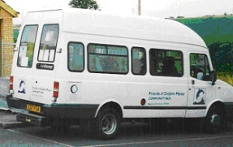

In January we ran 3 trips to see our
Patron Billy Pearce in Cinderella at the
Bradford Alhambra. A number of you
commented on how great the show
was and how much you enjoyed it.
Our thanks again to the Rothwell Lions for sponsorship of two of the trips, and to the Co-op Community Fund which allowed us to provide an extra trip.

Feedback forms for the Morley Amateur Operatic Society Production of Sleeping Beauty also said it was an excellent show.
So January 2018 has been a great Panto season!!

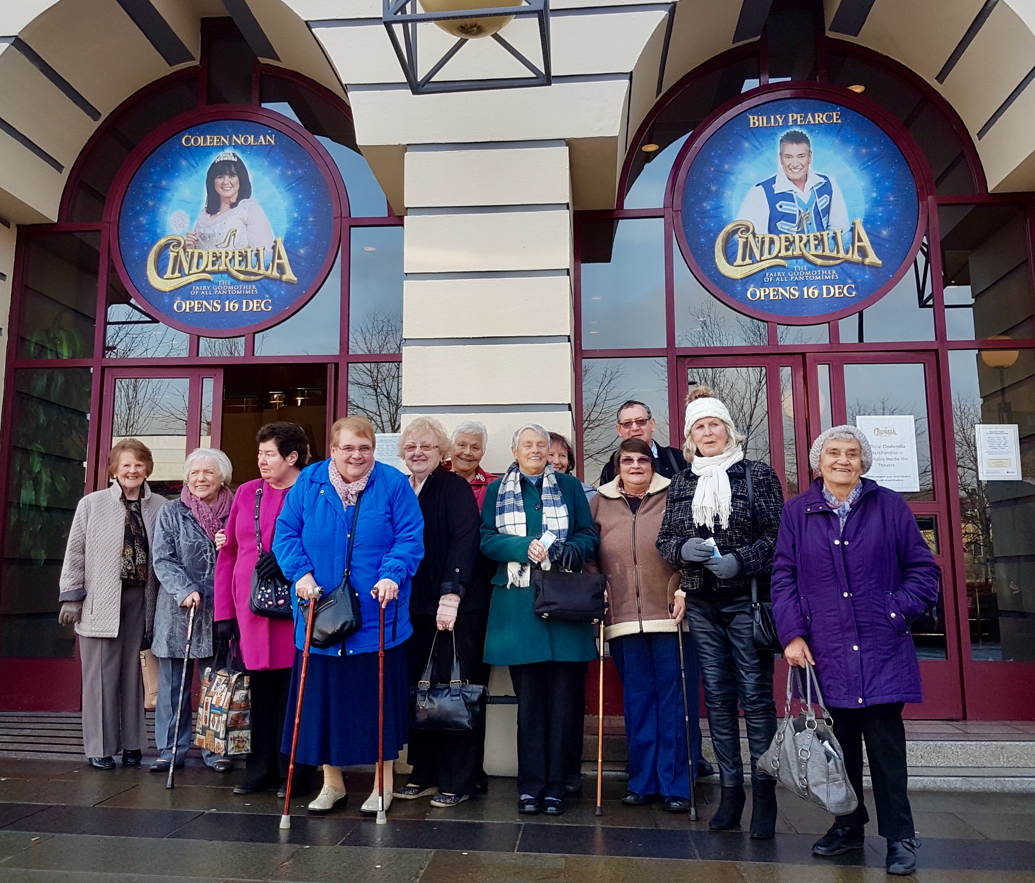

GRANTS and FUNDRAISING
FDM Easter Raffles
Val and Katy will be putting together an Easter Hamper. Tickets will be on sale on trips from the 1 March.

The local Co-op stores are also supporting us with an Easter Hamper Raffle.

If you have any items you can donate – please pop them into the office or pass them to a driver.

Our thanks to…..

PWC Foundation for a generous donation of £500. This will be a big help towards the cost of insuring our buses.

FDM will be collecting in Morrisons on Thursday 15 February. Thanks to everyone who has volunteered to help. Please do stop and say hello if you happen to be shopping that day.

Please turn over for more news…….

Social Club News
The Social Club is running a trip on Saturday
3 March to the Victorian Old Time Music Hall event at Wakefield Cathedral. We have reserved a table at the Cathedral Café for 1pm, so you have time for a bit of light lunch or a cuppa, (not included in the price) before the show starts.

We also have a trip to Beverley on Saturday
10 March, with opportunity to visit the lovely Beverley Minster, or have a wander around the Market and shops.

Please see the enclosed programme for more information about trips in March.

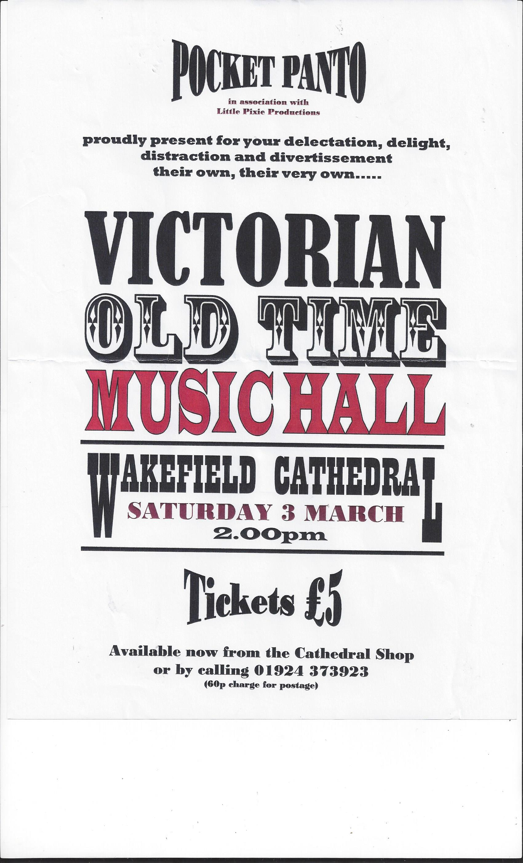

FDM is very pleased to welcome the following new User Groups

Carlton Cozy Club
Rothwell Tenants & Residents Association
Swillington Mothers Union

If your community group would like to make a booking please contact Val on
Monday, Tuesday, Thursday and Friday Mornings for more information.
0113 288 9000
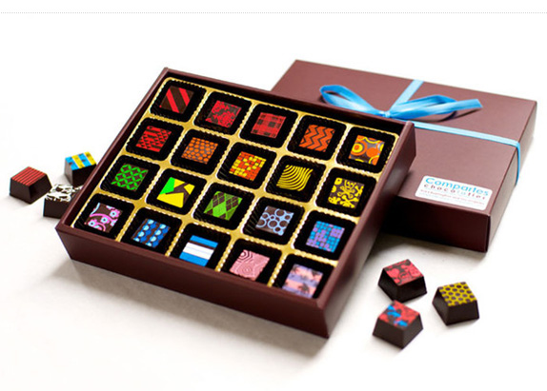

VOLUNTEER DRIVERS
The aim of the charity is to help reduce isolation and loneliness amongst the elderly and people with a disability within the community. If you or anyone you know would be interested in joining our team of volunteer drivers please contact the FDM office for more information.
0113 2889000 - 8.30am to 12.

____________________________________________________________________________
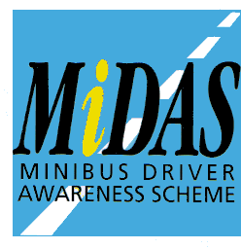
FDM offer both in House & Outside Agencies MIDAS Training

