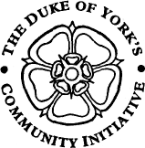
FDM Newsletter
Summer 2016
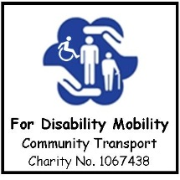
FDM – For Disability Mobility
Supporting Health, Choice & Social Inclusion through accessible community transport
106 STONE BRIG LANE, ROTHWELL, LEEDS, LS26 0UE
Email: fdmbus@tiscali.co.uk Web site: www.fdmbus.org.uk Tel: 0113 2889000
__________________________________________________________________________________________________

Welcome!

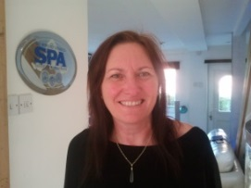
Welcome to Gail. Our new Social Club Project Co-ordinator. Gail comes with a breadth of knowledge in business support. Over the next few months you will see lots of new ideas relating to organised trips, the website and development on our social media sites, Facebook and Twitter.
If anyone has any suggestions for future trips and new ideas please contact Gail on 0113 2889000. Her normal working week is Monday, Wednesday, Thursday and Friday 12pm until 4pm.
Since last year, FDM have had a packed programme of visits, from Theatre trips to see performances such as ‘Into the Woods’ to garden centres and cinema visits. The upcoming months you will find a wide variety of trips to suit all. See programme on reverse.

AN UPDATE FROM THE TRUSTEES

Following on from our last meeting in November. We can now confirm that by the end of July we will be in receipt of our 2nd minibus. This will be a 16 seater, so we will be able to offer our trips to much larger groups.
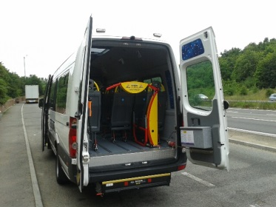

We would also like to welcome two new Group Users: Swillington Focus Group and The Elderberries’ Hope you enjoy your trips!
For economic reasons, we have had to take a look at our pricing structure. In order to keep costs low for you and for us, we are going to offer a two tier pricing structure for our trips. We will have 6 dedicated pick-up and drop of points, see list below, offering a discounted price of £2.50 less. But for those who are unable to get to a drop off point we will still offer our door to door service.
Pick up and Drop off Points:
Rothwell: Morrison Car Park
Woodlesford: Lidl
Methley: Community Centre
Kippax: Co-Op
Swillington: Tesco
Garforth: Factory Shop Car Park

VOLUNTEER PRESENTATION
The Trustees would like to invite members to our Volunteer Presentation taking place on Thursday 28th July at 10am at the Oulton Institute followed by light refreshments. Our Patron Christine Talbot will present our Volunteers with a certificate in recognition of their support over the past 5yrs, 10yrs & 15yrs..
The presentation will be followed by a bus management meeting to which all members are welcome. Please contact the office Tel: 0113 2889000 or email: info@fdmbus.or.uk if you would like to attend.

FUNDRAISING
Since our last newsletter we held a Mayday cuddly toy Tombola that raised £114. Thanks to all who took part, supported, donated, purchased and manned the stall.
We would now like to draw your attention to our next Tombola being held at the Rothwell Carnival on 9th July. To find us just follow that bus!!

SOCIAL CLUB TRIPS: July and August 2016

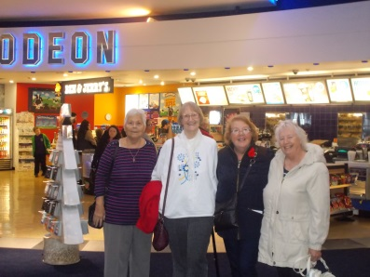
As the summer is now upon us, we have a very wide programme of activities to suit all. The trips arranged so far are listed below.
Those members who have previously been with us to the cinema or who have expressed an interest in the Cinema Club will be contacted once dates, times and movie details are available. If you are interested in joining us, then please contact Gail on 0113 2889000. We often arrange a meal too either before or after the movie, so you have chance to catch up with friends.

JULY 2016 Bookings taken from:
7th July Boundary Mills 22 June 2016 £22.50
16th July Tong Garden Centre 27th June 2016 £12.50
24th July Day to Bridlington & the Stained Glass 6th July 2016 £17.50
Centre
26th July Cinema (Showcase for a Change)! 6th July 2016 £12.50
31st July Burnby Hall Gardens 13th July 2016 £27.50
AUGUST 2016
2nd August Sewerby Hall & Open Top Bus 4th July £22.50
(Afternoon tea and bus ticket extra)
11th August Cinema 18th July £12.50
14th August Shopping experience Junction 32 27th July £ 7.50
20th August Alhambra Theatre ‘Wicked’ 27th July £37.50
8th August Bridlington & Stain Glass Centre 10th August £22.50

Don’t forget to discount £2.50 from total price for pick up points. !!!
All Social Club bookings are taken BY TELEPHONE ONLY on 0113 2889000 from 12.30pm on the date stated. Full FDM Social Club Booking Terms and Conditions are available on request or by visiting our website – www.fdmbus.org.uk

