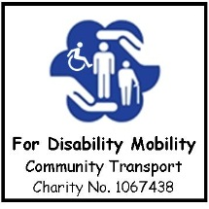
Could you be a Volunteer Driver?
Are you looking for something fun to do but rewarding?
Do you like to drive?
Drive to suit you and your lifestyle!

Would you like to help someone who feels isolated?
How about making a difference and put a smile on someone’s face!

Receive a non-taxable mileage reimbursement?
WE are looking for YOU!

If so come and meet us!

FDM is a registered charity that operates a transport scheme in the Leeds area. The FDM SOCIAL CLUB arranges a variety of trips throughout the year and we provide central pick up points and a door-to door service.

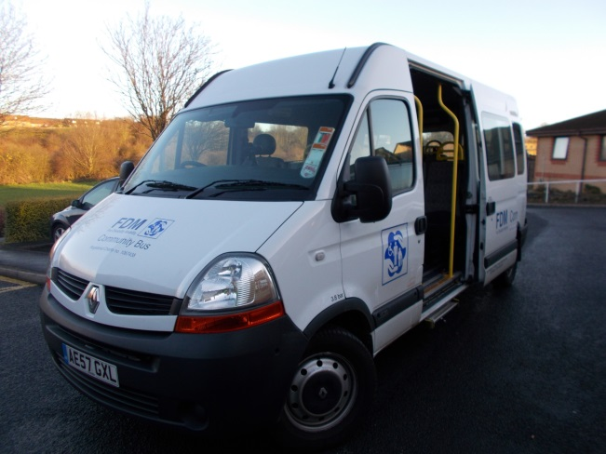

The FDM SOCIAL CLUB allows people the opportunity to visit places of interest, meet new people, socialise with friends and to visit places that would normally be restricted to them.
The aim of the charity is to combat isolation and loneliness amongst the elderly and disabled within the community.
Our website is: www.fdmbus.org.uk
106 Stone Brig Lane, Rothwell, Leeds, LS26 0UE, Tel: 0113 2889000 or email: info@fdmbus.org.uk

